Quick heads-up before you start

Dear Participant, Context Engineering 101 is an introductory course that includes hands-on demos to help you understand the concepts. Please note that hands-on practice is optional.

If you would like to try the hands-on demos, please note that Docker Desktop, Flowise, and LangSmith are non-catalog items, hence you cannot submit a ServiceNow request to install them on Cognizant devices. You may use your personal laptop for the demos, or we can provide a non-persistent virtual lab with the required software.

This document provides

- Non-persistent lab details
- Steps to use Flowise in virtual lab
- How to get Azure OpenAI API key

Non-persistent virtual lab

Non Persistent Virtual Lab Link : IIHT Practice Lab

The above link opens the Cognizant Learn course for the IIHT Practice Lab. Click Start to launch the lab in a new window. The lab is SSO-enabled, so you do not need to enter login credentials.

This is a non-persistent lab for 4 hrs, so any configurations or data you create will not be saved for your next session.

Steps to use Flowise in Virtual lab
- After connecting to the virtual lab, you can switch to full-screen mode by clicking the icons highlighted in the red box in below image.
- If virtual lab prompts for back-up, please choose Skip or opt out options.
- The first step is to start Docker Desktop. In the virtual lab, click the Docker Desktop icon highlighted in the red box on the desktop screen.
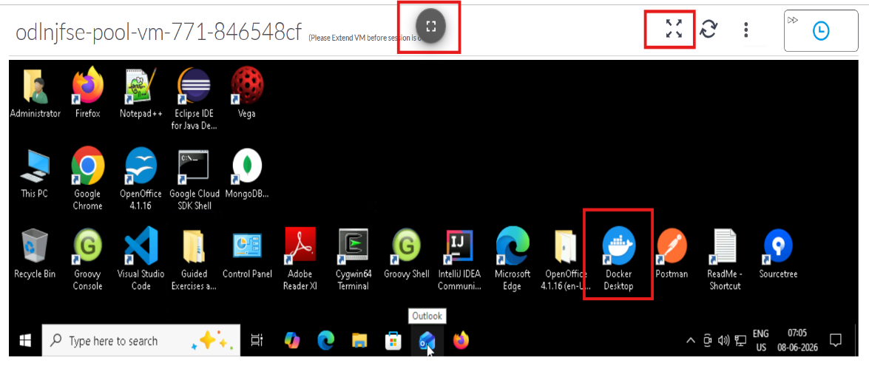

- Open PowerShell by typing “PowerShell” in the taskbar search box.
- In the PowerShell terminal, enter the following command to start Flowise.
Docker run -d -p 3000:3000 flowiseai/flowise

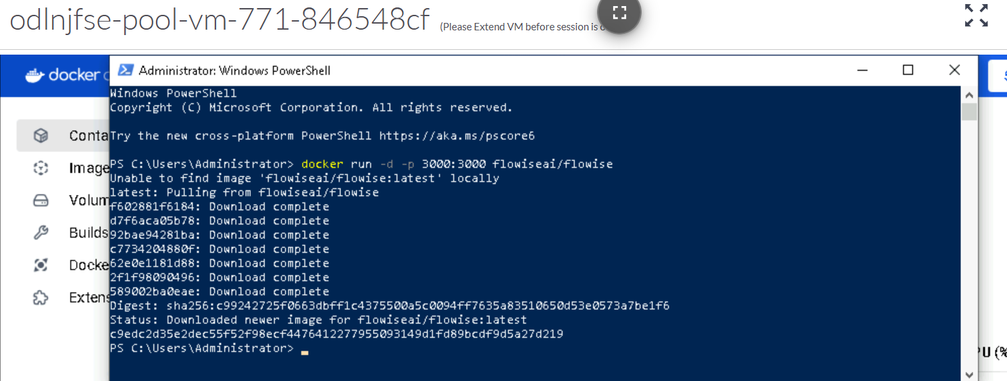

- In Docker Desktop, you can see Flowise running in the Containers window on port 3000.
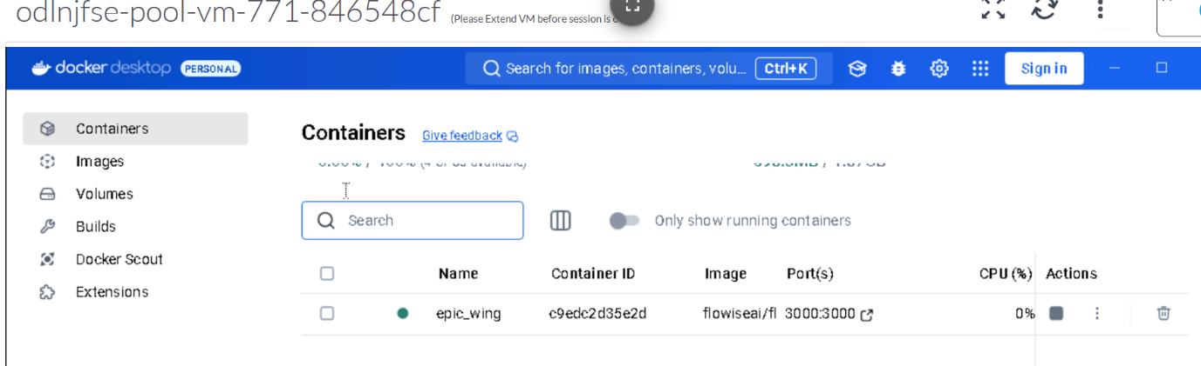

- To open the Flowise app, enter https://localhost:3000 in your browser. Please provide your personal email id for sign up to flowise.

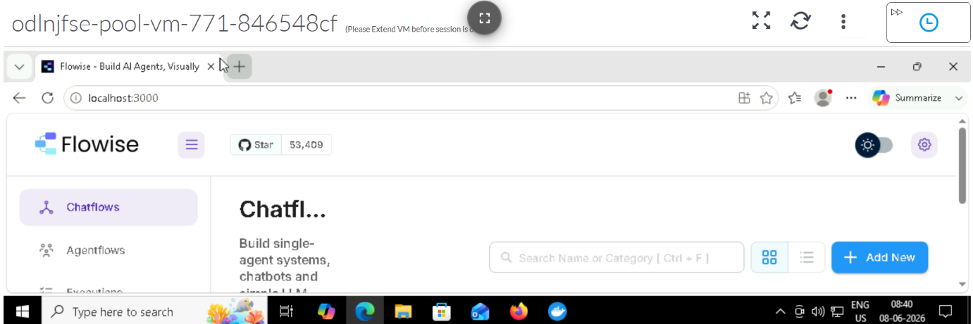

How to get Azure OpenAI API Key

- You need Azure cloud access to request an Azure OpenAI API key.

- Submit a Cloud Orchestration Request. For instructions, see CyberSec Arch & Gov - Requesting and Accessing a Cloud Environment (Cloud Orchestration).
- Cloud Service Provider: Azure
- Environment scope: Cognizant internal use
- Regulated data in the environment: No
- Data classification: Public
- Cloud environment type: Innovation
- VPN access required: No
- Use Generative AI: Yes

- After you receive access to the cloud environment, generate the Azure OpenAI API key at the portal below and use the same key in the Flowise application.
https://portal.azure.com/#view/Microsoft_Azure_ProjectOxford/CognitiveServicesHub/~/OpenAI

